

**PSYCHOLOGY AO1**

Submitted by: Sohaib Sarosh Shamsi

Class: Psych 4-B

Submitted to: Ms Shahtaj

Date of submission: 21/3/2023

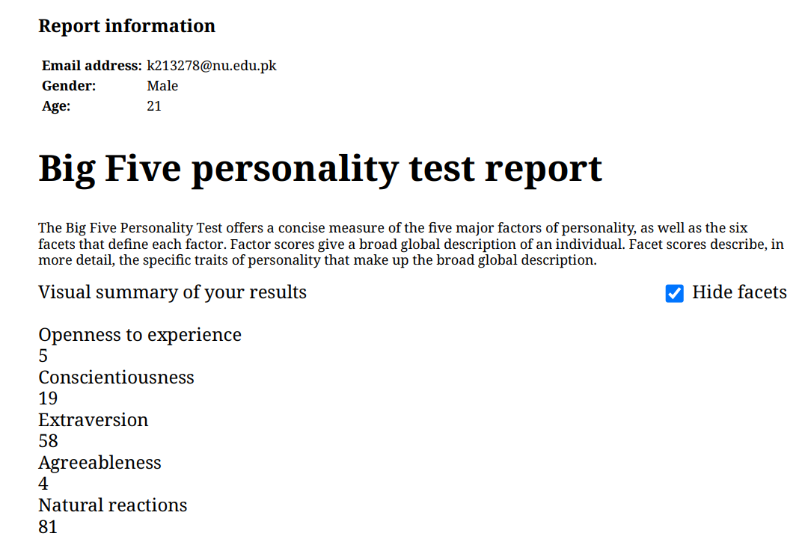

I usually don’t experiment new cuisines, cultures or try new dining places.



I prefer flexibility and adaptability and don’t like rigid or overly structured environments.



I enjoy interacting with others and forming connections. In group, I prefer to have direct leadership roles where I can make decisions.

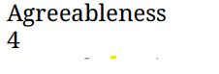

I am resistant to new ideas, skeptical of others' perspectives, driven by a desire to win and be the best.

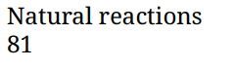

I easily get stressed out especially during exam days.